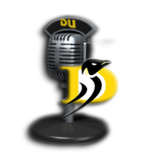
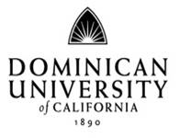
Communications Department
DU Radio Class
Melba Beals, Stuart Horne

Student Radio Station Staff
Duration of Staff positions are for one semester, and may be renewed upon review by the General Manager and Communications Director.
Staff uphold and police Station standards of behavior.
Student staff may qualify for academic credit.

Student Operations Director (1 position):
Assists Station Manager in all station affairs including:
Ensuring up-time
Oversees station email
Interface with Staff in meeting deadlines, etc.
Maintain on-air announcements and PSA’s

IT Manager (1 position):
Oversees technical issues related to:
Uptime and transmission quality
Current available technologies
Current broadcast software options
Playlist Auto-Schedule

Music Director (1 position):
Manages music for playlists and rotations
Handles music related email
20 new songs per week added to rotation and documented
20 songs per week archived
Website monthly Top 5
Monthly artist spotlights.

Sports Director (1 position):
Schedule, coordinate and prepare athletics broadcasts.
Help train and support sportscasters with on-air equipment.
Write sports briefs for on-air announcements including
Upcoming events, matches, etc.

Marketing Director:
Responsible for maintaining and developing station advertising and awareness
Station liaison to depts. and clubs
Maintain relationships with the Habit, Myspace, Marin.org, Craigslist, Community Calendar, IJ, Provost Newsletter, etc.

Volunteers
It is the Station’s mission to educate, inform, and entertain the campus community. Students, faculty, staff, and alumni are welcome to volunteer and are held to the same standards as radio students. Volunteers are evaluated and approved on an individual basis.

