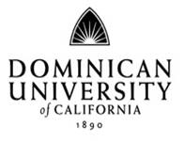
Communications Department
DU Radio Class
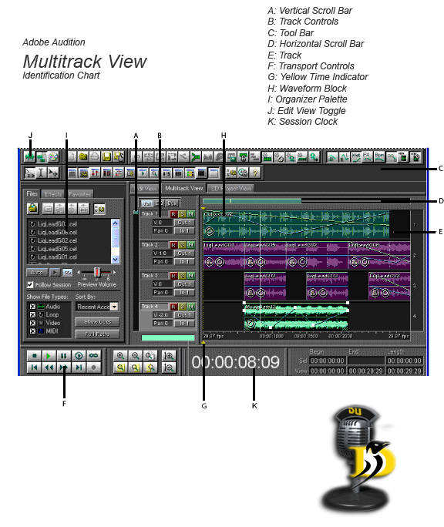
Melba Beals, Stuart Horne

